**Return To School – Setup flows**

**Overview**

* These flows are examples designed to easily do the first-time upload of student records from SIS (Student Information Systems) to Dataverse. Testing these flows in your implementation is required before running these in production.
* The ***Contact – Create Contacts From SDS Graph*** *&* ***School - Create Schools from SDS Graph*** *flows* have been tested to create 100k contact records. The average run time was 2 hours.
  + These flows do not support the following capabilities:
    - Deletion of records from Dataverse: This must be done manually.
    - Create contact records for non-teaching staff.
  + For each school, an email will be sent to notify if the run was successful or not.
* The ***Contact – Create Guardians From SDS Graph*** *flow* has been tested to process the guardians of 20k students. The average run time was 3 hours.
  + Note that this has not been tested to process the guardians of more than 20k students.
  + The API that retrieves the student’s guardian information is currently in ***beta*** release, testing is required before running this flow in production.
* The ***Scheduled - Create Parent/ Guardian Contacts &***  ***Scheduled - Create Student Parent Relationship*** *flows have been tested to create 5000 contacts and relationships. The average run time to create the contacts & relationships was 1 hour for each flow.*

**1 – Create contacts by using Graph API calls**

**Required Permissions**

* We need Global Admin Access to Create and Grant Admin Content for Azure AD (ACTIVE DIRECTORY) App registration.
* We need the CRM System Admin to import the solution and to change Power Automate.
* CRM System Admin should have an Outlook license.

**Prerequisites for using flows to read data from Graph and write it to Dataverse**

* Return To School 1.1
* Global Admin Access is required to take the steps below
* The user will need to register for a new App in [app registration portal](https://go.microsoft.com/fwlink/?linkid=2083908).
* The registration process is available step by step at <https://docs.microsoft.com/en-us/azure/data-explorer/provision-azure-ad-app#create-azure-ad-application-registration>
* The user must make sure to note down the Application/Client Id and Secret.
* Copy the Tenant Id 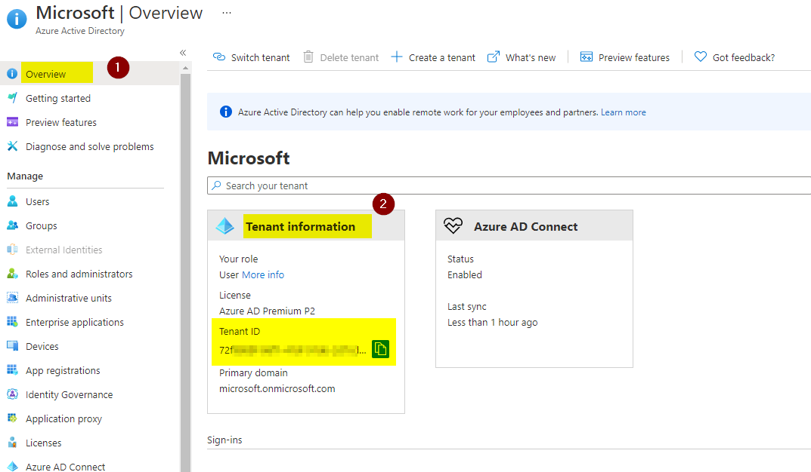
* These Tenant Id, Application/Client Id and Secret must be configured in later steps; copy and paste them in a secure place.
* Once the Azure AD Application registration is done, provide the following API Permissions on the app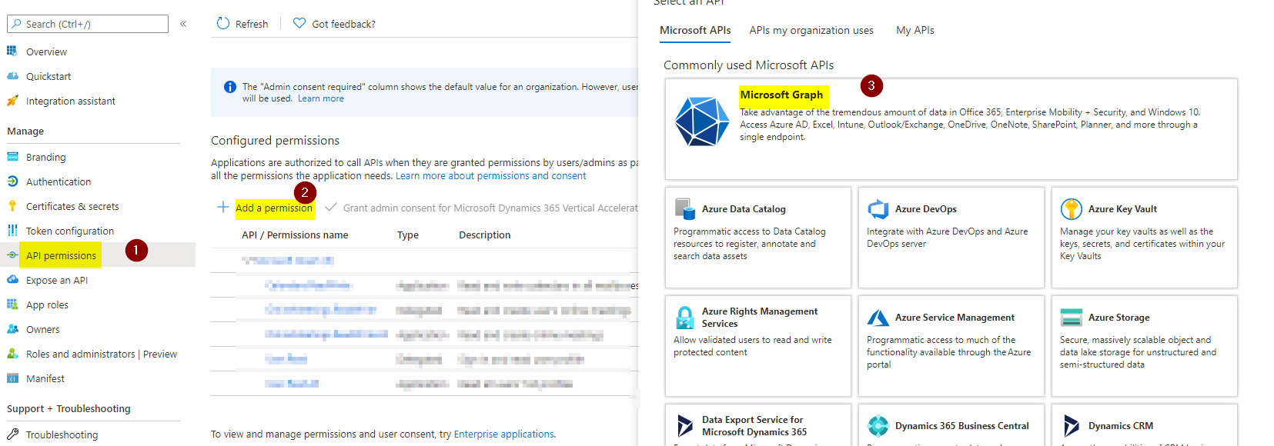
* Select Application permissions 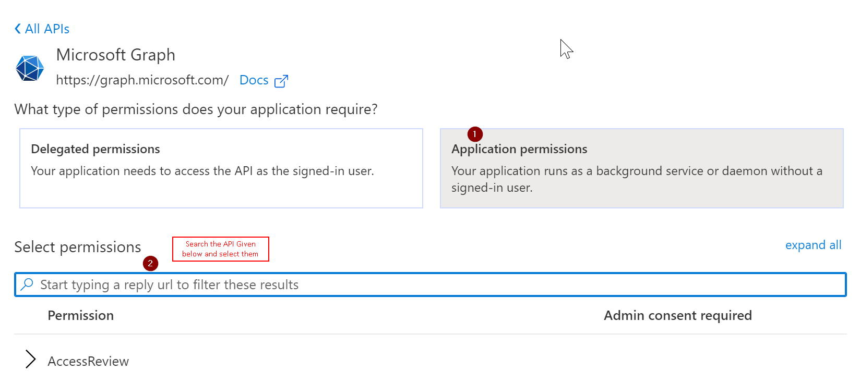
* Below is a list of permissions that is required:
  + Directory.Read.All
  + EduRoster.Read.All
  + User.Read.All
* Once all the permissions are given, click on **Grant Admin Content** as shown below. This requires Global Admin Access.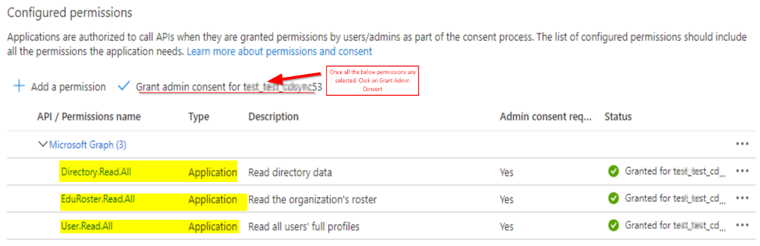

**Import Return To School – Setup Flows Solution**

Once you download **Return to School – Setup Flows** solution from GitHub, perform the steps below:

* Navigate to [https://make.powerapps.com/](https://us.flow.microsoft.com/) and login with your credentials
* On the top right corner of the screen, click on **Environments** and select the Environment that you want to import this solution into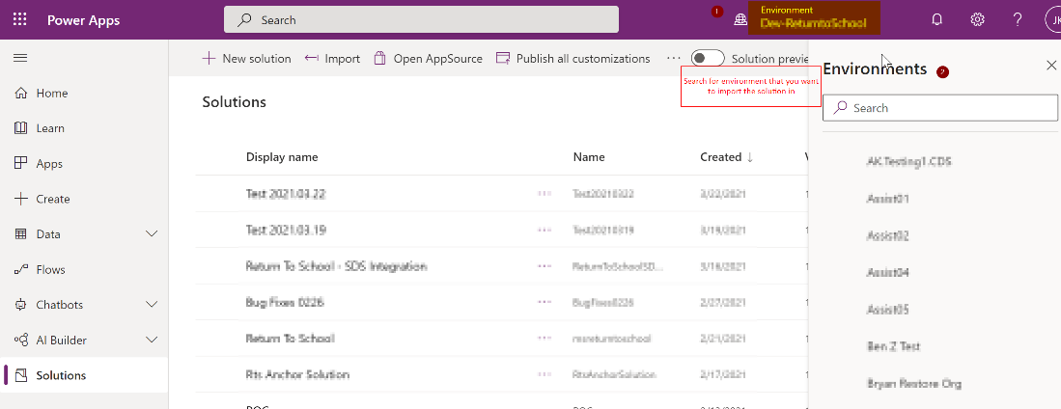
* After the Environment is selected, you will see **Solutions** on the left panel of the screen. Click on it.
* Click on the **Import** button on the command bar at the top of the screen
* The **Import** screen will be opened
* Click on the **Browse** button and select the solution that you have downloaded earlier and Click **Next**. 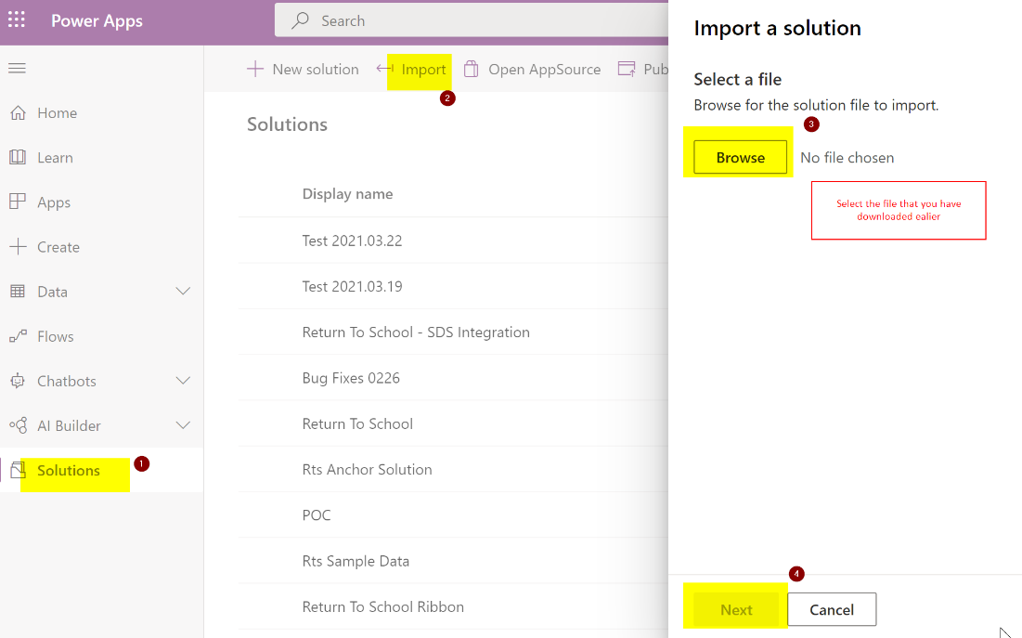
* Wait for the screen to show up the solution details.
* Provide a Connection Reference. If none is available, please create one by selecting **New Connection** as shown below
* Click Import 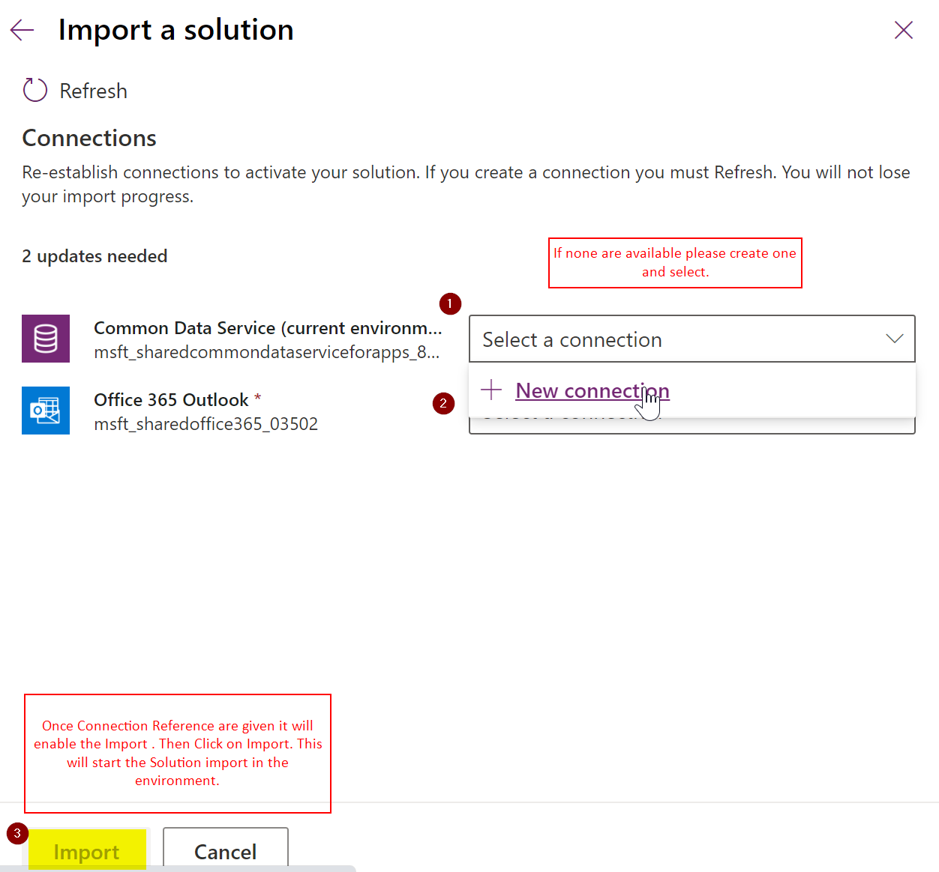
* At this point, the system will ask for the JSON required for the environment variables. You can add the values for the JSON string or skip and add later (instructions on how to add the json E**nvironment Variables** is described in a separate section below).
* Once import is done, click **Publish All Customizations**.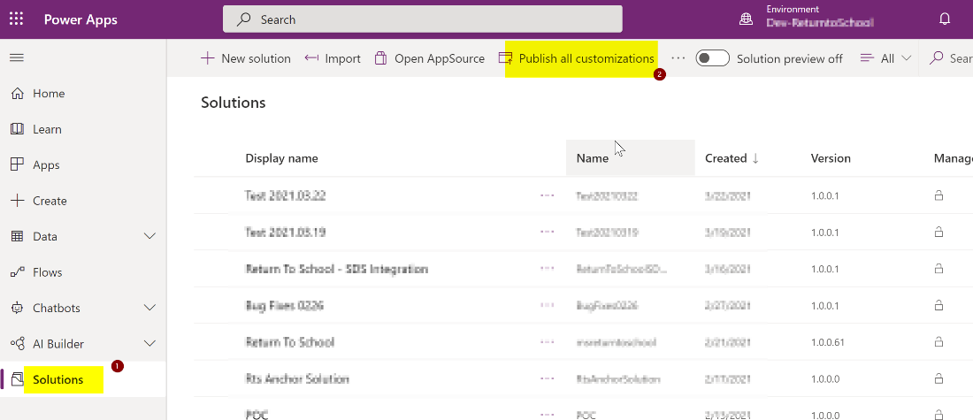.

**Environment Variable**

* After Solution is imported, navigate to **Apps** and Click on “**Return to School Management”** Model Driven Apps 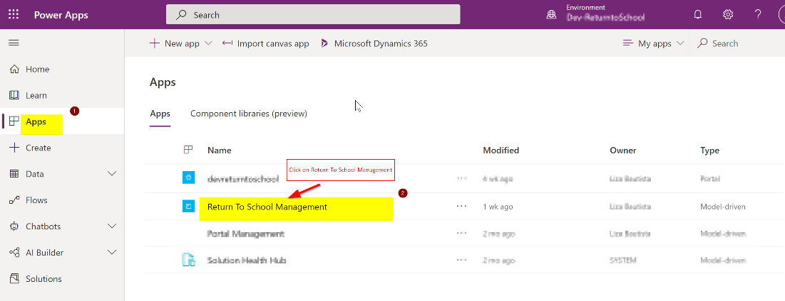
* Open Advance find in CRM.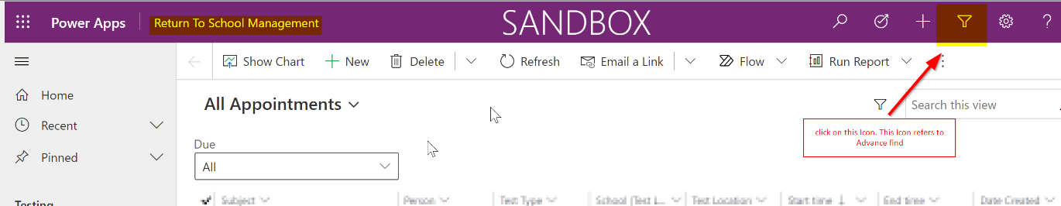
* As shown below, build the same query in advance find and Click Results.

Schema Name equals “**msft_graphconnectorvariables**”

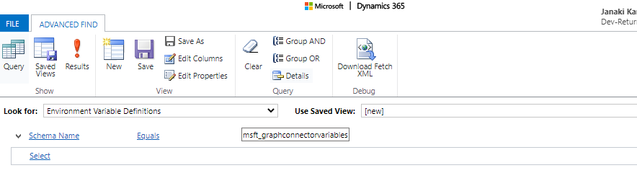

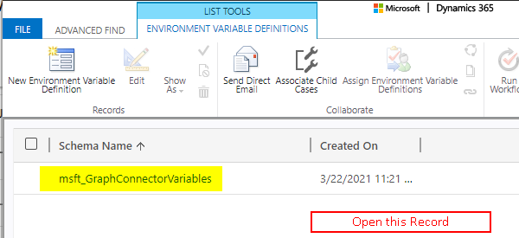

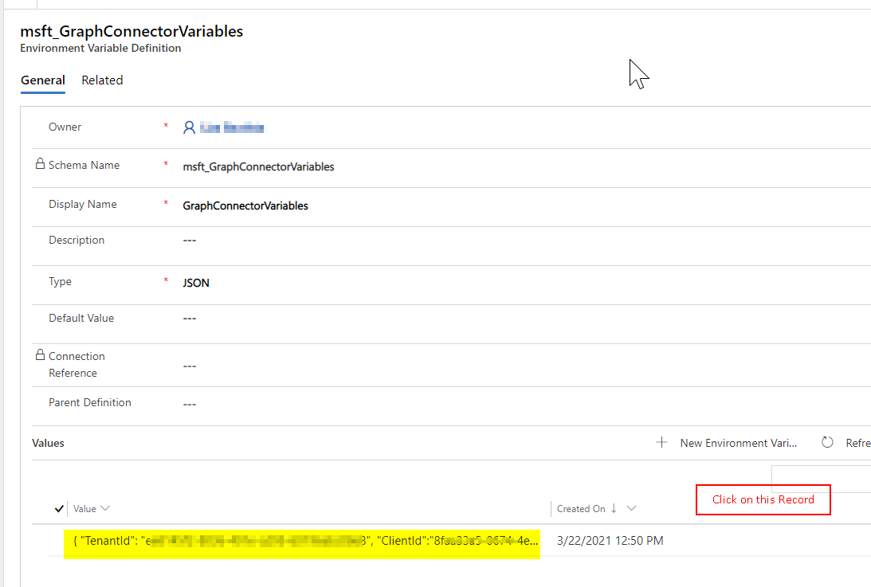

* Update Environment variable json string with the following details to configure the cloud flows:

{  
"TenantId": "",  
"ClientId":"",  
"Secret":"",

"Notification Email Address":""  
}

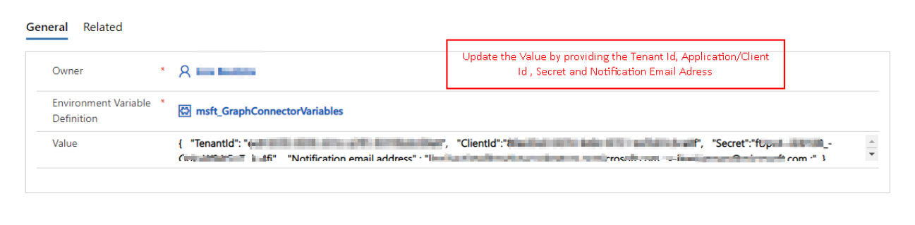

* **Example** 
  + Copy and paste the tenant id, Client Id and Secret from the above **Prerequisite** step into below JSON string.
  + You can have multiple persons email address by separating with semi colon (;). **Example:** [Test1@microsoft.com](mailto:Test1@microsoft.com); Test2@microsoft.com.

{

"TenantId": "xxxx",

"ClientId": "xxxx",

"Secret": "xxx",

"Notification email address": "xx@microsoft.com; xx@microsoft.com;"

}

* Click Save.

**Flow Configuration**

* Open the Solution and Click on the flow “***School - Create Schools from SDS Graph***”. 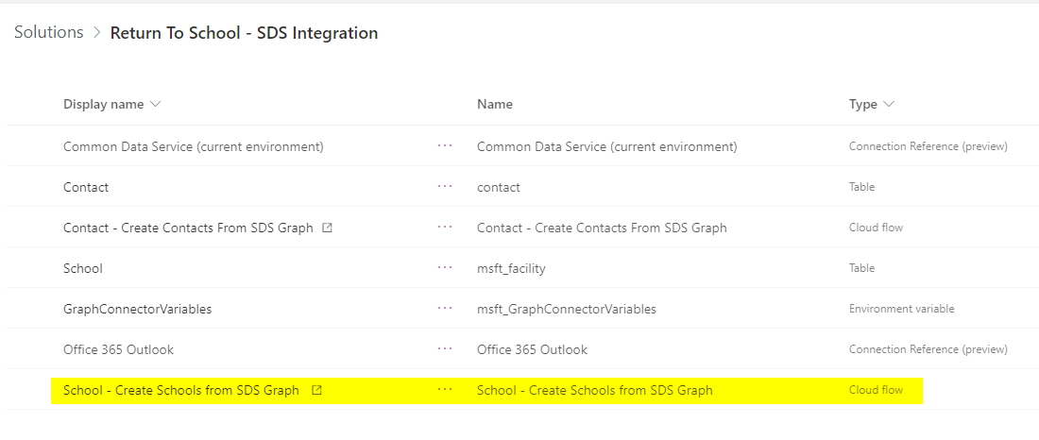
* In the command bar you will find **the Edit** button click on it. 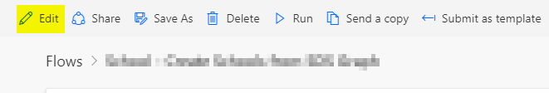
* This Flow is set to run once every week at 1AM in CST. If you want to change this settings Click on the Recurrence step.

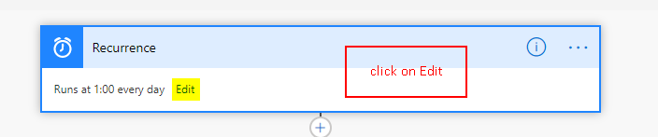

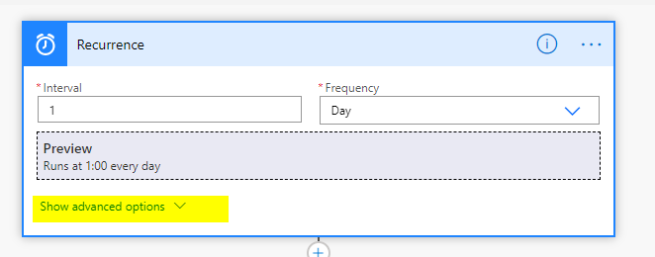

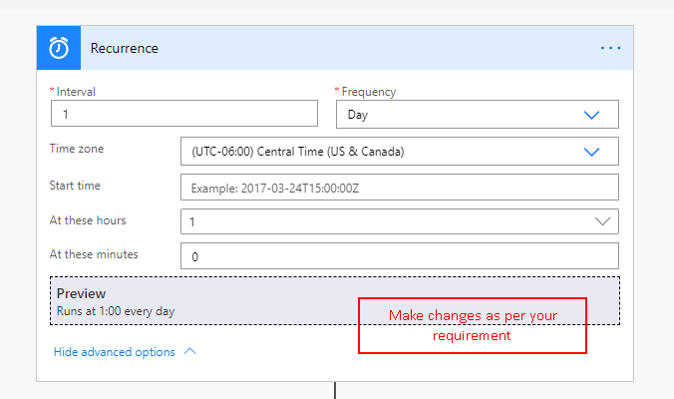

* Once all these changes are done, click **Save** on the top right corner of the screen
* Turn on the Flow **Contact – Create Contacts From SDS Graph** and Flow **School – Create Schools from SDS Graph** as shown below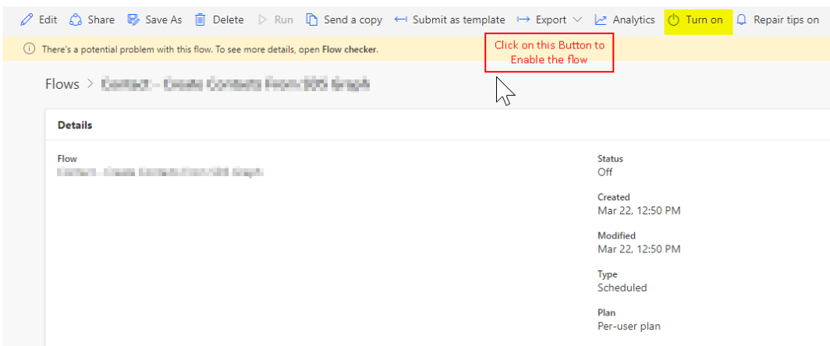
* Test the **School – Create Schools from SDS Graph** flow to make sure everything is setup correctly. 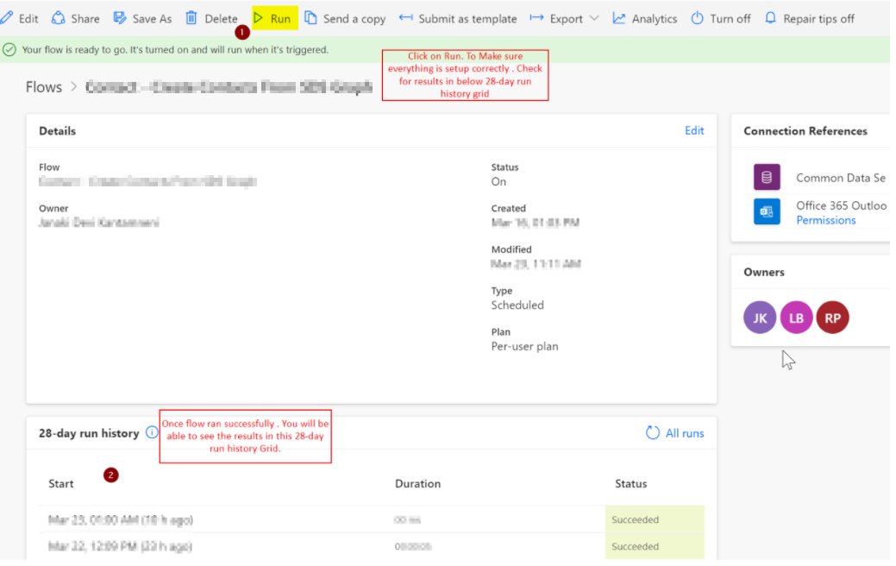
  + Since this is a scheduled flow, we don’t need to run it manually every time. It will run on its own according to the configuration you have set up on the trigger.
  + This flow will iterate through each school and will call the **Contacts – Create Students from SDS Graph** child flow to create the student or faculty contacts.
  + Optional: If you have less than 20k students, you can test the ***Contact – Create Guardians From SDS Graph*** *flow* to create guardian records. This should be scheduled to run only after the student contacts have been imported to Dataverse.

**2 – Create parent/guardian contacts by using CSV files and SFTP**

This is another flow example of importing parent/guardian records from a CSV file to Dataverse.

**Prerequisites:**

* SFTP Server: For this integration, the school district must have an SFTP server configured with an **“upload”** folder where schools can publish their data. For information about creating an SFTP server see: <https://docs.microsoft.com/en-us/samples/azure-samples/sftp-creation-template/sftp-on-azure/>
* CSV files with filenames and format described in <https://docs.microsoft.com/en-us/schooldatasync/parent-contact-sync-file-format>

* + Upload these files on under the **Upload** folder on the SFTP server

**Instructions on how to set up the Scheduled – Create Parent/Guardian Contacts flow:**

1. Configure the flow to be triggered on a schedule according to the implementation requirements. This can be set to run 1x a day, weekly or monthly.

1. Copy the “user.csv” file on to the SFTP Server. (Instructions to connect to SFTP Server manually and copy the csv files are given below after the flows configuration steps).
2. Make an SSH Connection to the SFTP Server & the set following details: connection name, host server address, username and password. After the connection is configured, set the name of the folder where the files will be picked up for processing.

1. Iterate through the files and check if the file is not a folder and has the file name “user.csv”.

1. If above criteria meet, then get the file content.

1. Now we skip the first line in the file (as it will contain column names of the csv files) and iterate through all the remaining lines in the file. For each line in the file we follow below process and repeat it until we reach the end of the file.
   1. Replace all the occurrences of comma (i.e., ‘,’) with a pipe symbol (i.e., ‘|’) and then split each line based on the pipe symbol to get the column values.

* 1. Check if there exists a Parent/Guardian with the email address from the csv file and contact type is Parent/Guardian in **Contact** Table

* 1. If the Parent/Guardian Contact doesn’t exist, we create a new contact in **Contacts** Table with the Email, FirstName, LastName, Phone , SIS ID (Student/Faculty ID) data from the csv file, Contact Type as Parent/Guardian for that parent/guardian.

We also set the Required Portal Access field to **Yes** in the Create Parent or Guardian Contact Step

1. Finally, if the Rename Variable value in the flow is true, then we rename the csv file name on SFTP Server by appending “Processed_CurrentTimeInUTC” before the actual file name.

Instructions how to set up the **Scheduled - Create Student Parent Relationship** flow:

1. Configure the flow to be triggered on a schedule according to the implementation requirements. This can be set to run 1x a day, weekly or monthly.

1. Copy the “guardianrelationship.csv” file on to the SFTP Server. (Instructions to connect to SFTP Server manually and copy the csv files are given below after the flows configuration steps).
2. Make an SSH Connection to SFTP Server and set the folder path where the csv files will be retrieved.

1. Iterate through the files and check if the file is not a folder and has the file name “guardianrelationship.csv”.

1. If above criteria meet, then get the file content.

1. Now we skip the first line in the file (as it will contain column names of the csv files) and iterate through all the remaining lines in the file. For each line in the file, we follow below process and repeat it until we reach the end of the file.
   1. Replace all the occurrences of comma (i.e., ‘,’) with a pipe symbol (i.e., ‘|’) and then split each line based on the pipe symbol to get the column values.

* 1. Check if there exists a Student with SIS ID value from the csv file, contact type is Student and GraphId is not null in **Contact** Table. If exists we get the contact id for that contact.

* 1. Check if there exists a Parent/Guardian with the email address from the csv file and contact type is Parent/Guardian in **Contact** Table. If exists we get the contact id for this contact.

* 1. Once we have both student and parent contact id, we create a relationship mapping entry in **Related Persons** Table with relationship type as Parent/Guardian.

1. Finally, if the Rename Variable value in the flow is true, then we rename the csv file name on SFTP Server by appending “Processed_CurrentTimeInUTC” before the actual file name.

